KFS Order Instructions

Website: portal.uci.edu



- Click on KFS-Faculty & Staff’ tab
- Login with UCI Net ID
- Click on “Finances/KFS” tab
- Under the Purchasing section
- Click on UCIBuy or Requisition to create a new order
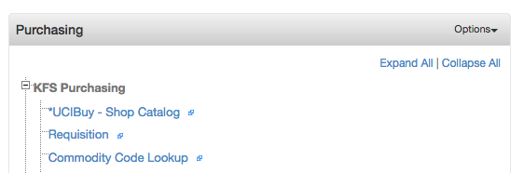

- If you select UCI Buy follow these steps: (For Requisition see next section)

- Select Vendor tab to shop or search under “Everything” to perform price comparisons among vendors
- Or select the Vendor you want to shop from and click “Punchout” link if available
- Add/delete items to cart as needed
- Once all items are added in cart
- Click on view cart to edit if necessary then check out/transfer cart or proceed to checkout
- Click on create KFS Requisition

- Fill in/complete the following KFS Requisition Tabs (document overview and delivery tabs)
- Click on “Collapse all” in the upper right corner

- Click Show on Document Overview Tab (see below)
- Add vendor name to the end of the description field (Do NOT overwrite prefilled text)
- Enter Budget Code in the Organization Document number field (see below)
- Enter in Explanation field (Justification, PI name and Fabrication # if relevant)

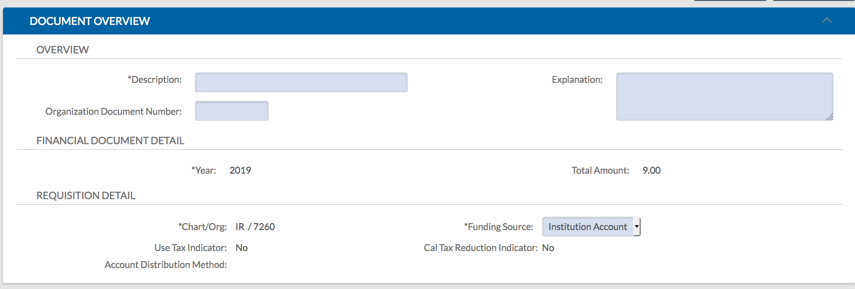

- Save at the bottom of the screen

- Click Show on Delivery Tab (see below)
- Add phone number, email, building code and room number, if not shown or automatically populated
- Add Delivery Instructions if applicable

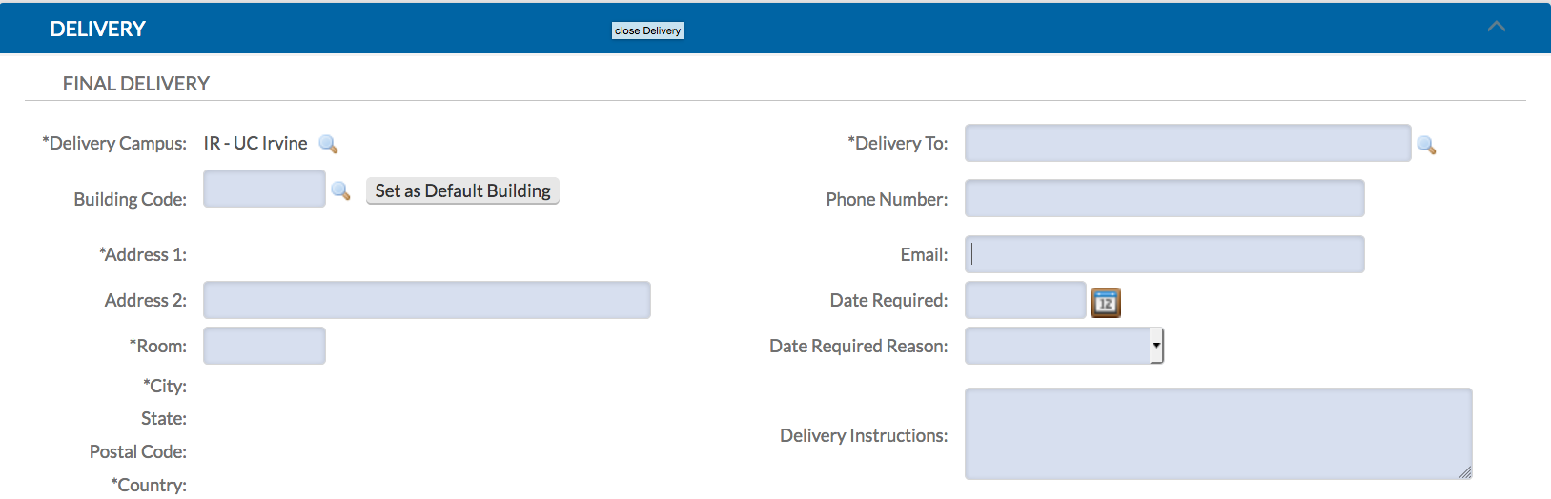

- Save at the bottom of the screen

- Vendor Tab and Items Tab is pre populated (Check to make sure it is correct)
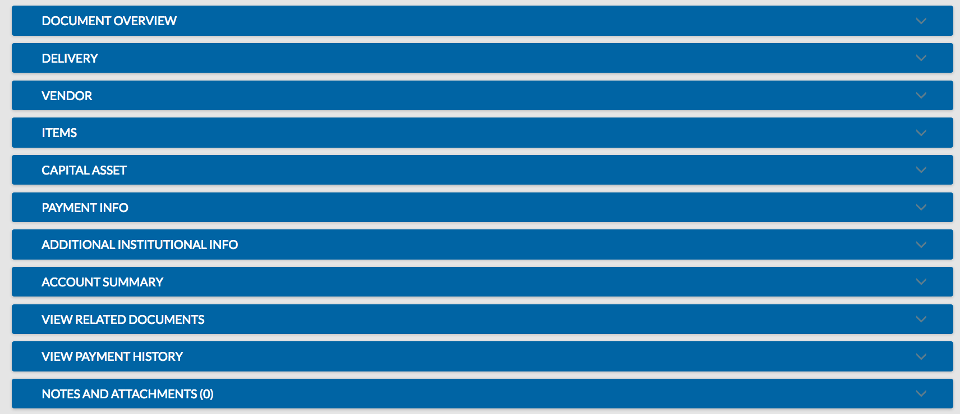

- For any notes or attachment for PS purchasing, click Show Notes and Attachments Tab (see below)

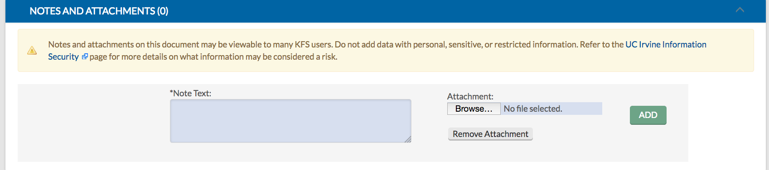

- Attach document(s) PDF only, then click Add tab at right
- Click Calculate then Save and then Submit

The UCI Buy requisition will route to PS purchasing once you see the message Document Successfully Submitted in your upper left corner

For Standard KFS Requisition follow these steps:

- Click on Requisition to create new order
- Fill in/Complete the following KFS Requisition Tabs (document overview, delivery, vendor and items Tabs)

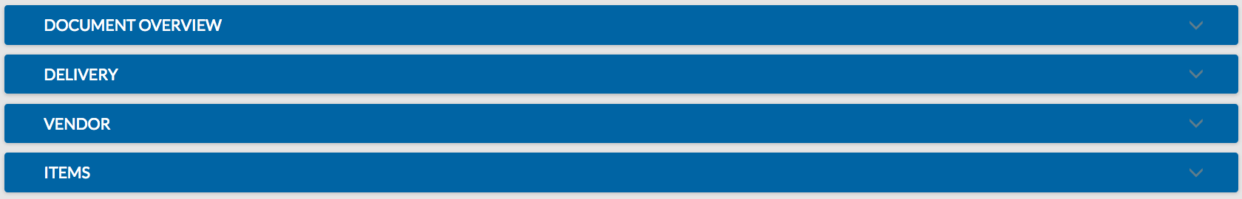

- Click “Collapse all” in upper right hand corner

- Click on the Document Overview Tab (see below)

- Enter vendor name in Description Field
- Enter budget code in Organization Document Number field
- Enter in Explanation field what project items are for, PI name and Fabrication # if relevant

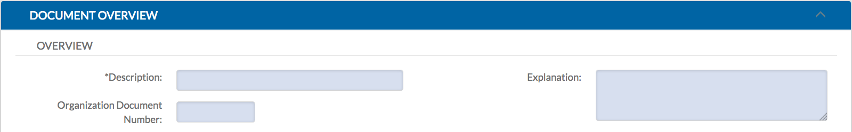

- Save at the bottom of the screen

- Click on the Delivery Tab (see below)
- Enter building name and room number (Rush orders requests and alternative off campus ship to address can be entered into Delivery Instruction box)

- Save at the bottom of the screen

- Click on the Vendor Tab (see below)
- Enter vendor name, address, telephone #, and contact name
- Save at bottom of the screen
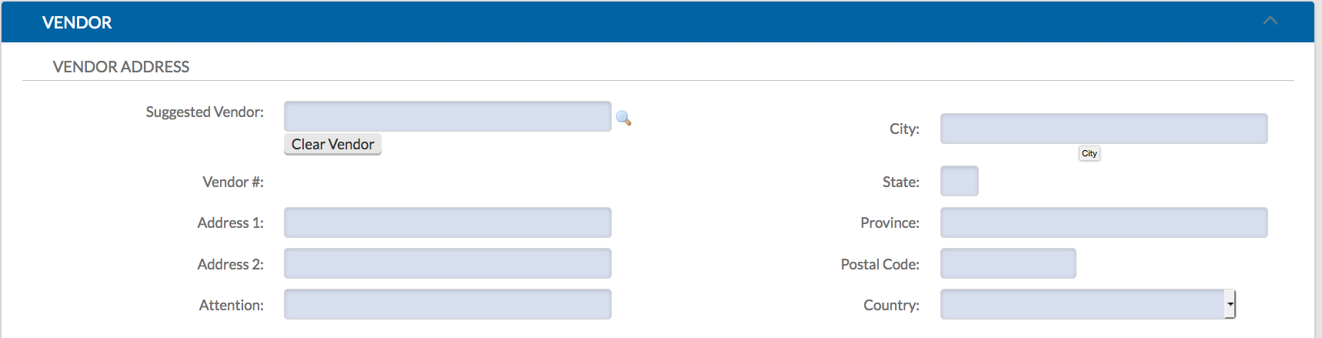

- Click on the Items Tab (see below)
- Enter quantity, UOM, catalog #, commodity code #: 41121800 (use for all items), description, unit cost, then  button on the right enter in additional items as necessary (same as above)
- Save at bottom of the screen

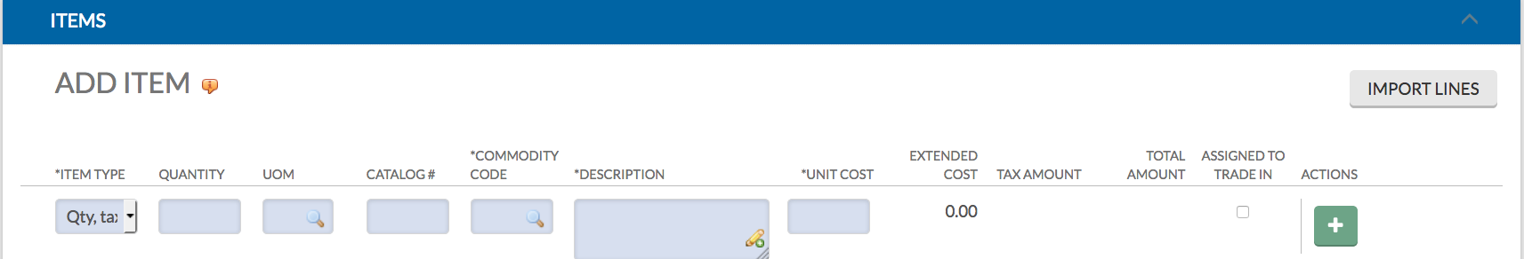

- If adding notes to PS purchasing or attaching quotes, sole sources, or other documents
- Click the Notes and Attachments Tab
- Add notes and/or attach documents (PDF only)
- Click “Add tab” at right
- Click Save then Calculate and then Submit at bottom of the screen

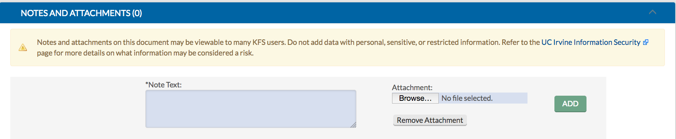

The requisition will route to PS purchasing once you see the message Document Successfully Submitted in the upper left corner

